|  |
| --- |
| **LAB 3xx Assignment** |

**Type: Long Assignment**

**Code:**

**LOC:**

**Slot(s): 5**

**Title:** Manage Employee

# Background

# Program Specifications

Program a web site add, view and delete Employee

**Features:**

This website contains 3 main functions

* Function 1 : Default page :

o Display list employee contain: (PIC 01)

* + First name
  + Middle name
  + Last name
  + Department
  + Category

o Create employee: ( PIC 02)

* Data input
  + - First Name (required)
    - Middle Name
    - Lase Name (required)
    - Name Alias
    - Gender
    - Date of Birth (Date format)
    - Joining date (Date format)
    - Department (required)
    - Category (required)
    - Email(Required)
    - Phone number
    - Marital status
    - Address
    - Experience (time)
* “Create” button click

Date of Birth + Joining date: Date format (Date picker) (Pic 3)

If any required field is blank, show message “… can not be blank” (Pic 3)

If save into database successfully, show alert or message “Create success”. If Error occur show alert or message “Create fail!”

* “Cancel” button click: Do not save anything and back to “Default page”
* Function 2: View Employee details(Pic 4)

Redirect to View Detail page when user click view detail button in **Employee List.**

* Function 3 : Delete a employee.

Delete employee by click to **Delete** button (Pic 1), Confirm before delete (Pic 5), Show alert or message “Delete success” and reload **View Employee List** page if delete successfully, and “Delete fail” if error occur or cannot delete.

You do not need to write interface for admin control panel, you can add data manually (use SQL SERVER Management studio).

Note: All data must be load from database, not hard code in page.

***Expectation of User interface:***

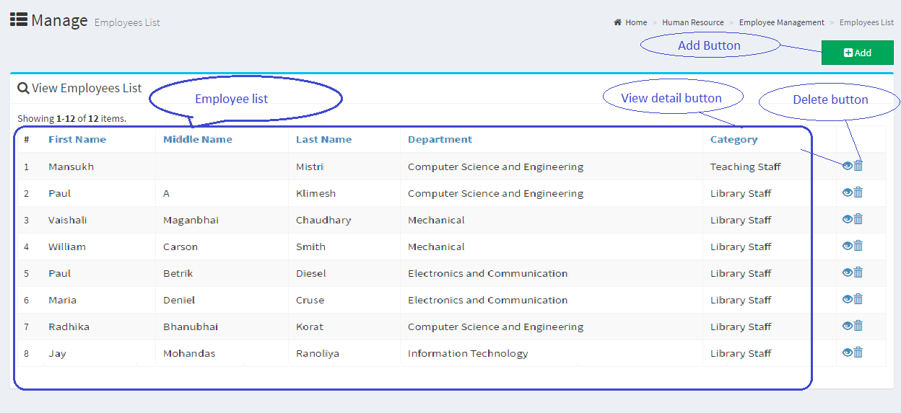

PIC 1 : Default Page

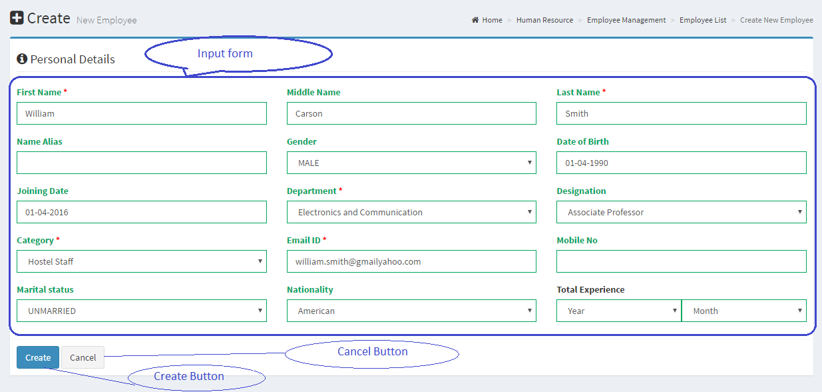

Pic 02 : Add Employee

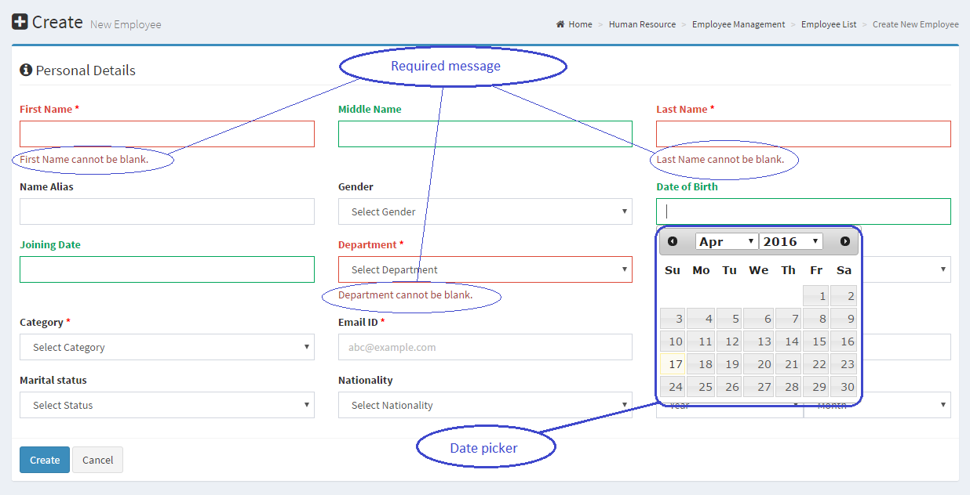

Pic 3

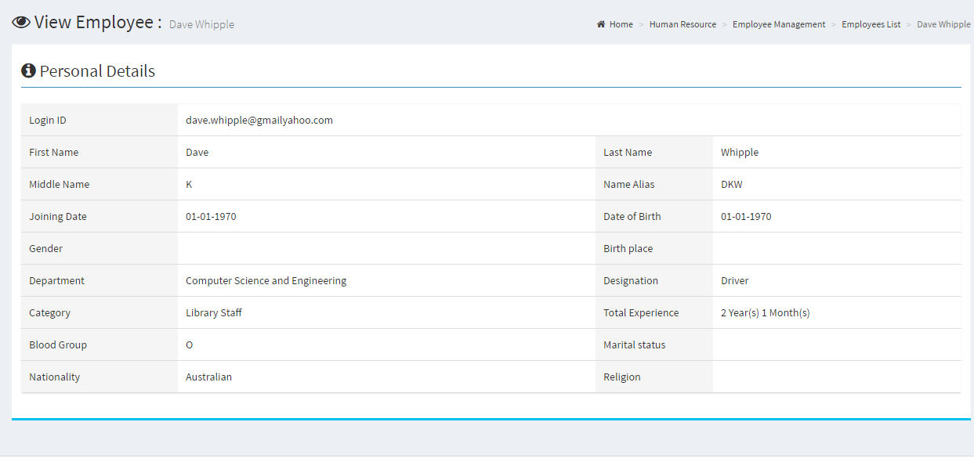

PIC 04 : View information of employee

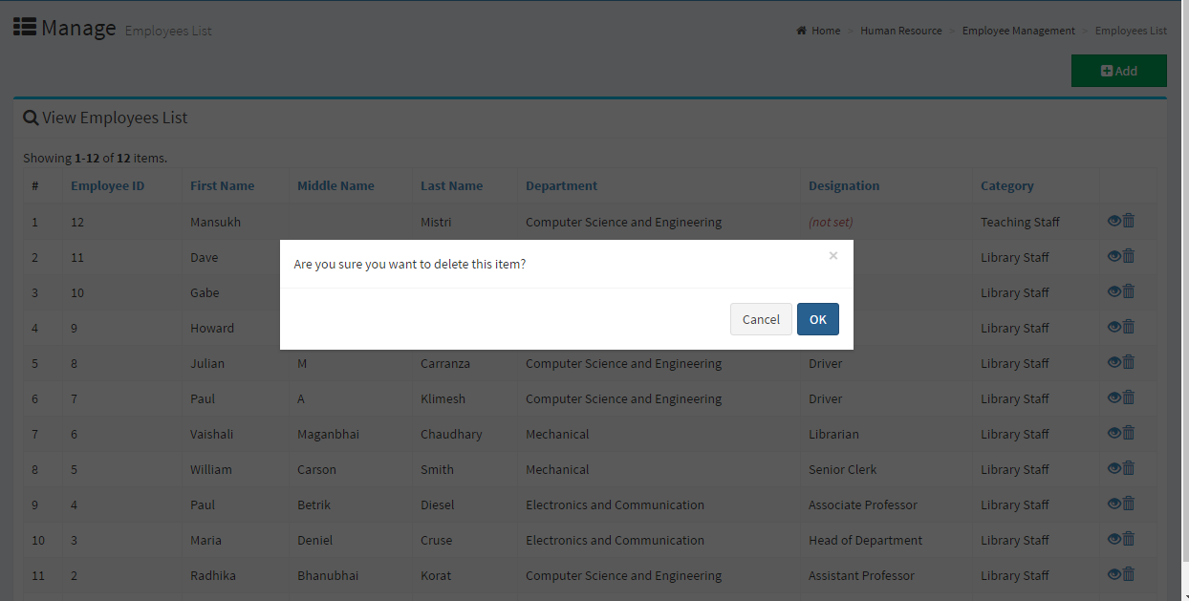

Pic 5: Confirm Dialog

# Guidelines

* Step 1 : Create web layout
* Step 2 : Create prototype
* Step 3 : Design database base on created prototype
* Step 4 : Code & Test